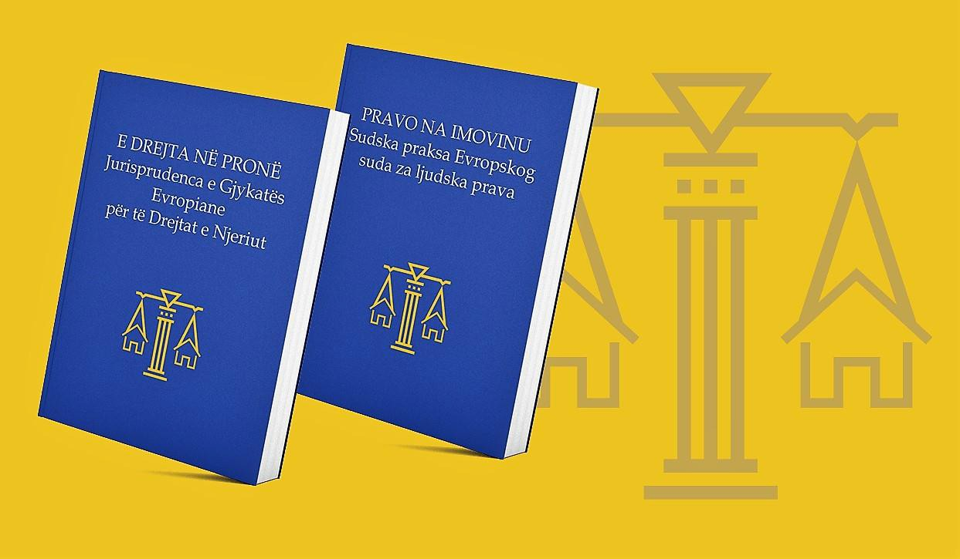

PI COMMUNICATIONS FOR USAID PRP

QUARTERLY REPORT NO. 18

Property Rights Program (PRP)
FY 2018
(July 1 – September 30, 2018)

OCTOBER 2018

DISCLAIMER
The author’s views expressed in this publication do not necessarily reflect the views of the United States Agency for International Development or the United States Government.

QUARTERLY REPORT NO. 18

Property Rights Program (PRP)
FY 2018
(July 1 – September 30, 2018)

OCTOBER 2018

This report was prepared by:
Tetra Tech
159 Bank Street, Suite 300 Burlington, Vermont 05401 USA Tel: (802) 495-0282
E-Mail: international.development@tetratech.com

Tetra Tech Contacts:
Brian Kemple, Chief of Party
Bedri Pejani Street, Building 3, Floor 3 10000 Pristina, Kosovo
Tel: +381 (0)38 220 707 Ext. 112
Email: brian.kemple@prpkos.com
John (Jack) Keefe, Senior Technical Advisor/Manager  159 Bank Street, Suite 300 Burlington, Vermont 05401 USA Telephone: (802) 495-0557 Email: jack.keefe@tetratech.com | Thomas McCann, Project Manager 159 Bank Street, Suite 300  Burlington, Vermont 05401  Tel: (802) 495-0552  Email: Thomas.McCann@tetratech.com

Cover Photo: PRP has unveiled its publication, in Serbian and Albanian versions, of summaries of 144 key decisions of the European Court for Human Rights concerning property rights. By operation of the Kosovo Constitution, ECHR decisions are directly applicable in Kosovo; yet they are poorly known there, because they are usually issued in French and English only. The cover photo shows the backdrop used on the screen at the visibility event that PRP held to present the publication.

TABLE OF CONTENTS
ACRONYMS AND ABBREVIATIONS 3
INTRODUCTION AND BACKGROUND 5
EXECUTIVE SUMMARY 6
INSTITUTIONALIZATION OF CASE FLOW MANAGEMENT REFORMS 7
SUMMARIES PUBLISHED IN ALBANIAN AND SERBIAN OF 144 DECISIONS OF THE EUROPEAN COURT OF HUMAN RIGHTS ON PROPERTY RIGHTS 8
DEVELOPING TRAINING MODULES ON LEGAL TOPICS 8
INITIATIAVE LAUNCHED FOR MODERN NOTIFICATION PRACTICE THAT STRENGTHENS DUE PROCESS 8
PRP concludes successful series of regional roundtables for moc’s 9
PROJECT ACTIVITIES 11
OBJECTIVE 1: BETTER COORDINATION AND POLICY PRIORITIES 11
Sub-Objective 1.2: Reform Legislation to Achieve NSPR Reform Objectives Developed and Implemented 13
OBJECTIVE 2: IMPROVED COURT PROCESS RELATED TO PROPERTY CLAIMS 18
SUB-OBJECTIVE 2.1: CASE FLOW MANAGEMENT REFORMS INSTITUTIONALIZED 18
SUB-OBJECTIVE 2.2: GUIDELINES DEVELOPED TO UNIFY JUDICIAL PRACTICE IN PROPERTY RIGHTS DISPUTES 18
SUB-OBJECTIVE 2.3: EXPEDITED PROCEDURES DEVELOPED 21
OBJECTIVE 3: ENHANCED WOMEN’S RIGHTS TO USE PROPERTY IN PRACTICE 23
SUB-OBJECTIVE 3.2: CONDUCT TRAININGS FOR JUDGES ON WOMEN’S PROPERTY RIGHTS ISSUES AND GENDER SENSITIVITY 25
OBJECTIVE 4: IMPROVED COMMUNICATION, ACCESS TO INFORMATION AND UNDERSTANDING OF PROPERTY RIGHTS 26
Sub-Objective 4.1: Improved Municipal Service Delivery and Dissemination of Legal Information to Assist Citizens to Effectively Exercise their Rights to Property 26
PROJECT SPECIFIC PERFORMANCE INDICATORS 31
SUCCESS STORY 37
PROJECT BRIEF UPDATE 35
MEDIA 39
PUBLICATIONS 39
PROJECT STAFF 40

ACRONYMS AND ABBREVIATIONS
AI Administrative Instruction
ATRC Advocacy Training & Resource Center BIRN Balkan Investigative Reporting Network CCP2 Civil Code Project 2
CDCS Country Development Cooperation Strategy CFM Caseflow Management
CoM Court of Merit
CSO Civil Society Organization
DO Development Objective
ECHR European Court of Human Rights E4E Engagement for Equity
EU European Union
EUSR European Union Special Representative (in Kosovo) GCG Gender Coordination Group
GIZ Deutsche Gesellschaft für Internationale Zusammenarbeit (“German Corporation for International Cooperation GmbH)
GoK Government of Kosovo
IQC Indefinite Quantity Contract
IR Intermediate Result
ISBN International Standard Book Number
JSSP Justice System Strengthening Program
KCA Kosovo Cadastral Agency
KCLIS Kosovo Cadastre and Land Information System KJA Kosovo Judicial Academy
KJC Kosovo Judicial Council
KPA Kosovo Property Agency
KPCVA Kosovo Property Comparison and Verification Agency LA Legal Associate
MCO Municipal Cadastral Office
MESP Ministry of Environment and Spatial Planning MGO Municipal Gender Officer
MLGA Ministry of Local Government Administration MoJ Ministry of Justice
NDS National Development Strategy NSPR National Strategy on Property Rights OPM Office of the Prime Minister

OSCE Organization for Security and Cooperation in Europe PRP Property Rights Program
PSA Public Service Announcement
SAA Stabilization and Association Agreement
SPO Strategic Planning Office
STARR Strengthening Tenure and Resource Rights
USAID United States Agency for International Development

INTRODUCTION AND BACKGROUND
The absence of an effective property rights framework in Kosovo weakens democratic governance, impacts human rights, disempowers women and impedes sustainable economic growth. The USAID/Kosovo Property Rights Program (PRP) assists the Government of Kosovo (GoK) to implement its National Strategy on Property Rights (NSPR), developed with PRP support, and strengthen property rights legislation; supports the development of improved court procedures and practices to efficiently adjudicate property claims and disputes; conducts public outreach campaigns to prompt changes in social attitudes and behavior concerning the ability of women to exercise their property rights and works closely with civil society organizations to support related activities; and improves service delivery in municipalities to increase the general public’s understanding of property rights and make it easier for citizens to exercise their property rights.

With the GoK adopting the NSPR in January 2017, PRP is now working closely with all relevant GoK bodies to implement the strategy’s recommendations. This includes assistance to strengthen the property rights legal framework by ensuring it is modern, clear, harmonized and well-integrated and implementation of activities to help citizens to formalize their property rights.

PRP has been working closely with the Kosovo Judicial Council (KJC) and three Courts of Merit (CoMs) to develop and pilot improved court procedures related to property claims. The piloting initiative has produced significant and demonstrable improvements in the CoMs’ efficiency and effectiveness in adjudicating property rights cases and offers a roadmap for institutionalizing these reforms throughout the judicial system. PRP has applied findings from its close collaboration with CoM’s to develop an initiative with the Supreme Court to produce guidelines for lower courts to accurately and consistently resolve complex property rights disputes. Results produced by PRP in these areas contribute to achieving USAID/Kosovo’s Country Development Cooperation Strategy Development (CDCS) Objective 1 “Improved Rule of Law and Governance that Meets Citizens’ Needs.” Improved legislation and court procedures also support creation of an Improved Economic Governance and Business Environment under the CDCS Development Objective 2 “Increased Investment and Private Sector Employment.”
PRP’s most recent National Survey on Property Rights demonstrates that PRP’s media campaign has sparked debate and discussion in Kosovo concerning women’s property rights (which was reportedly a taboo subject previously) and is producing positive changes in social attitudes and behaviors. PRP is continuing its national media campaign and grassroots public outreach activities on women’s property rights to reinforce these trends. PRP also provides technical assistance to USAID’s E4E partner and E4E sub-grantees (Civil Society Organizations (CSOs)) to develop and implement activities aimed at supporting women’s property rights and to complement PRP’s public outreach activities. In addition, PRP has completed preparations for the third and final (Endline) National Survey on Property Rights.

At the municipal level, PRP is working with local administrations to improve their own practices and procedures and services to citizens related to property rights; provide citizens with useful legal information to enable them to more efficiently transact their rights to property; and engage more effectively with their communities on property rights issues.

EXECUTIVE SUMMARY

SUMMARY OF RESULTS FOR THE REPORTING PERIOD AND KEY ACHIEVEMENTS
This Quarter saw PRP advance its initiatives significantly under all four Objectives. Under Objective 1, PRP has continued to support the timely development of legislation to implement the NSPR and assist the GoK in tracking its implementation. Under Objective 2, two CoMs have taken steps to institutionalize the Caseflow Management (CFM) reforms introduced by PRP, which have resulted in greater efficiency and improved court performance in adjudicating property rights cases. PRP has advanced its initiative with the Supreme Court to produce guidelines for lower courts to improve their substantive practice in property rights law. Under Objective 3, PRP continued its public outreach on women’s equal property rights with a range of activities. Under Objective 4, PRP has moved forward a number of initiatives that are designed to improve municipal governments’ services to their citizens. In addition, PRP has produced two publications that will help bring Kosovo’s property rights regime into line with best international standards and practices: summaries in Albanian and Serbian of 144 key decisions of the European Court of Human Rights that concern property rights; and an Albanian translation of European valuation standards.

OBJECTIVE 1: BETTER COORDINATION AND POLICY PRIORITIES

PROGRESS TO IMPLEMENT THE NSPR

To date, action has been taken on 89% of the pieces of legislation contemplated by the three-year NSPR Action Plan, and the Government has begun implementing 66% of measures called for by the Action Plan. Activities are being implemented on time cross all five NSPR objectives. A status update for each piece of legislation is discussed below.

INITIATING STATUS UPDATE ON NSPR IMPLEMENTATION

PRP and the Strategic Planning Office of the Office of Prime Minister (SPO) agreed to conduct a comprehensive analysis of the implementation of the NSPR during the past six months.

ASSISTING STAKEHOLDERS IN REPORTING

PRP assisted the MoJ in preparing a Summary Report for the Minister of Justice to present at the meeting of the Inter-Ministerial Coordination Group on Human Rights; and in updating the Economic Reform Programme (ERP) on activities on property rights. PRP also provided comments on the Draft Report prepared by the EU Twinning Project on Support to Kosovo Institutions on the Stabilization and Association Agreement; and reviewed the MFA’s Draft Analyses on the State of Economic Diplomacy. The MoJ requested PRP to conduct this review to identify recommendations that bear on the National Strategy on Property Rights which could have an impact on economic development and increasing investment.

CLOSE COORDINATION CONTINUES WITH THE EU-FUNDED SUPPORT FOR THE CIVIL CODE PROJECT, PHASE 2 (CCP2)

PRP and CCP2agreed on the approach for legislating property rights in the Civil Code and special laws developed under the NSPR. PRP documented the agreement, with USAID comments in a memo signed by both projects and jointly presented to the Ministry of Justice (MoJ).

INFORMING INTERNATIONAL STAKEHOLDERS ABOUT THE KPCVA LAW

PRP met with representatives of, respectively, the US Embassy, United Nations High Commissioner for Refugees (UNHCR) and the European Union Special Representative (EUSR) in separate meetings to explain the thrust of the proposed amendments and secure support for this initiative.

EXPLORING COLLABORATION WITH THE OFFICE OF THE OMBUDSPERSON ON PROPERTY RIGHTS ISSUES
Potential areas of collaboration with the OO include: supporting a fully open and transparent cadastre; eliminating property transaction tax; eliminating requirement to demonstrate payment of property tax to obtain property rights certificates contrary to Kosovo law; amending Law on Anti- Money Laundering to exempt transactions prior to 2005 to reduce informality.

ALBANIAN TRANSLATION OF EUROPEAN VALUATION STANDARDS COMPLETED AND PUBLISHED
PRP published the translation and is distributing copies to appraisers, judges, lawyers, notaries and relevant officials. PRP is also seeking to have digital versions of these texts posted in the web pages of the Kosovo Association of Appraisers and other institutions.

OBJECTIVE 2: IMPROVED COURT PROCEDURES RELATED TO PROPERTY CLAIMS

INSTITUTIONALIZATION OF CASE FLOW MANAGEMENT REFORMS
The Peje Basic Court has permanently hired Legal Associates (LAs) to carry out the functions defined in PRP’s CFM assessments to improve court efficiency. The hired LAs were previously trained and seconded to the court by PRP. The LAs contribution to court efficiency was recognized by the court and the KJC and the position will now become permanent with state funding.

IMPROVED CFM PRACTICES CONTINUE TO PRODUCE POSITIVE RESULTS
PRP’s support to the CoMs since December 2016 have assisted judges to issue a total of 10,625 decisions including 2, 059 decisions to dispose the case, and 8,566 procedural actions related to the first and second stages of a case to more efficiently and quickly advance the cases to final disposition.

PRP AND THE JUDICIAL STRENGTHENING SUPPORT PROJECT (JSSP) COLLABORATE TO PRODUCE COURT GUIDANCE

The two USAID projects combined JSSP’s Bench Book with PRP’s Practical Guide on the Adjudication of Property Rights Cases in Kosovo into a single product to help improve court performance. JSSP acknowledged the value of PRP’s contribution to include more practical guidance to resolve property claims and disputes which present particular legal challenges judges must resolve.

COLLABORATION WITH SUPREME COURT TO PRODUCE GUIDELINES ON PROPERTY RIGHTS DISPUTES

This initiative will assist the Supreme Court to help lower courts deal more effectively and uniformly with issues in property rights disputes. PRP has identified 139 Supreme Court decisions that address these issues and has helped the Supreme Court hire four legal assistants to support the judges to produce the guidelines.

SUMMARIES PUBLISHED IN ALBANIAN AND SERBIAN OF 144 DECISIONS OF THE EUROPEAN COURT OF HUMAN RIGHTS ON PROPERTY RIGHTS
PRP has produced a volume of 144 summaries in Albanian and Serbian of decisions of the European Court of Human Rights (ECHR) that concern property rights. ECHR decisions are incorporated into the applicable law in Kosovo and the summaries will assist judges and lawyers comply with ECHR guidance.

The Kosovo Supreme Court and Kosovo Judicial Academy have posted digital versions of the ECHR Case Summaries on their web sites and PRP supported a public event to raise awareness about the initiative and citizens’ human rights as they pertain to property.

DEVELOPING TRAINING MODULES ON LEGAL TOPICS
In close collaboration with the Kosovo Academy of Justice (KAJ), PRP commenced development of training modules on Gender Sensitivity; ECHR Practice in Property Rights; and Property Rights Issues in Kosovo Judicial Practice. PRP has identified and hired four local experts to provide STTA to develop these training modules, they will work closely with their KAJ counterparts.
AMENDING KPCVA LAW TO CREATE EXPEDITED PROCEDURES FOR ADDRESSING INFORMALITY
PRP prepared the Explanatory Memorandum to support the GoK adoption of the amendments. The draft legislation is now in Parliament.

INITIATIAVE LAUNCHED FOR MODERN NOTIFICATION PRACTICE THAT STRENGTHENS DUE PROCESS
PRP has commenced discussions with the Office of the Official Gazette (OOG) to publish notice of property rights proceedings and decisions issued by GoK institutions. PRP has provided the OOG with an analytical memorandum on the proposed initiative and a draft Memorandum of Understanding. Thus far the OOG has been very receptive.

OBJECTIVE 3: ENHANCED WOMEN’S RIGHTS TO USE PROPERTY IN PRACTICE

ROBUST MEDIA CAMPAIGN CONTINUES ON WOMEN’S PROPERTY RIGHTS

PRP arranged for existing public service announcements (PSAs) to be aired again, with a billboard campaign conducted in parallel to complement the PSA campaign. In addition, PRP finalized the concept and completed production of a new PSA that will begin airing in October 2018. PRP also arranged for the Head Banner in prominent social media to promote women’s property rights and PRP’s other outreach activities.

SUPPORT TO ENGAGEMENT FOR EQUITY (E4E) SUB-GRANTEE CONDUCTING OUTREACH IN GJILAN MUNICIPALITY

PRP has supported the E4E sub-grantee, “Gruaja Hyjnore,” with information leaflets and brochures for use in their lectures and dissemination activities. Gruaja Hyjnore held number of awareness- raising workshops and meetings with women in the Gjilani area, including in villages and with the high school students.

HELPING MGO’S INCREASE PUBLIC ENGAGEMENT IN SUPPORT OF WOMEN’S PROPERTY RIGHTS

PRP is working closely with Municipal Gender Officers (MGO’s) in Suharekë/Suva Reka, Mitrovicë/Mitrovica, Lipjan/Ljipjane, Gjakova/Đjakovica, Dragash/Dragaš, Viti/Vitina and Shtërpcë/Šterpce -- to develop joint plans of activities in their communities to support women’s property rights. In that connection PRP and the MGO from Suharekë/Suva, Reka held a workshop with the local assembly women’s caucus and municipal staff on women’s property rights. The workshop concluded with a list of recommendations from the participants on how local assembly members and municipal staff can support women’s property rights in their municipality.

PREPARATIONS COMPLETED FOR END-LINE NATIONAL SURVEY ON PROPERTY RIGHTS

PRP has awarded the subcontract to UBO Consulting (UBO) to conduct the end-line survey. It is expected that UBO will begin its work on or about October 1, 2018 and will complete it by the end of February 2019. UBO will survey 1,500 households, which is the number required to produce a statistically significant sample that is representative for the entire country.
OBJECTIVE 4: IMPROVED COMMUNICATION, ACCESS TO INFORMATION AND
UNDERSTANDING OF PROPERTY RIGHTS

PRP CONCLUDES SUCCESSFUL SERIES OF REGIONAL ROUNDTABLES FOR MOC’S
PRP completed its series of five regional (30 municipalities) training workshops on property registration service delivery, with the fifth regional workshop for MCO’s held in Peja/ Peć. The workshops were designed to focus attention and foster constructive discussion on specific challenges and problematic issues confronting MCOs that PRP has identified through its work with MCOs to date.

PRP prepared and distributed to all the participants a detailed analytical memorandum that described the issues and challenges that were discussed; included recommendations on how they can be addressed; and indicates where and how PRP will help address the problems identified.

MUNICIPALITIES POSTING PRP’S “HOW TO REGISTER...” BROCHURE SERIES ON THEIR WEBPAGES
PRP has produced brochures that provide citizens with guidance on registering property rights arising in four different scenarios (from inheritance; purchase and sale; court judgment; and gifts). Thus far, eleven municipalities have published digital copies of the brochure on their websites.
SECOND GENERATION E-KIOSKS BEING EXTENDED TO FOUR ADDITIONAL MUNICIPALITIES
PRP held a competitive procurement and concluded contracts with two subcontractors to upgrade six e-kiosks in four municipalities. PRP has also facilitated cooperation between each sub-contractor and the Kosovo Cadastral Agency (KCA) to ensure the e-kiosks are correctly linked to the Kosovo Cadastre Land Information System (KCLIS).

INITIATIVE NEARLY COMPLETED TO ELIMINATE BACKLOG OF UNREGISTERED TRANSACTIONS IN ŠTRPCE/SHTËRPCË MUNICIPALITY
PRP continued to provide technical assistance by way of an STTA Expert and intern to support the Municipal Cadastral Office (MCO) to eliminate its large backlog of unregistered property transactions. To date around 4,400 files have been entered into the KCLIS, out of an estimated 5,000 total. The backlog arose when the Municipal Assembly issued an order prohibiting registration of inter-ethnic transactions. The order was subsequently nullified, but during that time the number of transactions that were submitted for registration accumulated, and the MCO did not have the resources to register them and attend to ongoing duties. Approximately 90% of the backlogged files (5,000) will be registered by the end of October 2018. Further action will need to be delayed until January, owing to Kosovo law governing short-term and long-term employment.

MUNICIPALITIES SELECTED FOR NEW LEASING INITIATIVE
PRP has commenced an initiative to assist selected municipalities in leasing municipal arable land to the private sector. Following the conclusion of the regional workshops with MCO’s, PRP made fact- finding trips to ten potential partner municipalities to ascertain their officials’ level of support for this initiative. PRP also consulted with USAID AGRO, USAID EMPOWER, USAID P4D and USAID AKT- LS. On the basis of its findings PRP has proposed six municipalities -- Gjakovë, Peje, Gracanicë, Shtime, Malisheve and Istog – and USAID has given its approval.
IMPROVING THE LEGAL FRAMEWORK FOR LAND CONSOLIDATION

PRP has developed close contacts with the Ministry of Agriculture (MoA), which is responsible for land consolidation; and with the Deutsche Gesellschaft für Internationale Zusammenarbeit (GIZ) project that is assisting the MoA in this area. PRP has agreed to assist in amending the current Law on Land Consolidation. During this Quarter, PRP developed its own analysis and recommendations of the key issues that should be addressed and presented it to the MoA and GIZ. It is expected that the MoA will present these issues for discussion when it forms a working group to develop amendments to the Law.

PROJECT ACTIVITIES

OBJECTIVE 1: BETTER COORDINATION AND POLICY PRIORITIES
SUB-OBJECTIVE 1.1: NSPR REFORMS COORDINATED WITH AND BETWEEN GOK INSTITUTIONS

PRP continued to support the MoJ and GoK institutions in developing implementing legislation for the NSPR. PRP collaborated with the MoJ the Ministry of Environment and Spatial Planning (MESP), the Ministry of Local Government Administration (MLGA), the KPCVA, the SPO/OPM and other stakeholders advance development of legislation foreseen in the NSPR. The three-year NSPR Action Plan comprises a diverse portfolio of activities, legislation drafting, training and capacity development, and awareness raising. PRP has supported development of 89% of legislations described in the Action Plan, either as amendments to, or replacements of, existing laws. Out of the total 18 pieces of legislations to be developed, only 2 pieces of legislation have yet been addressed.-- amendments to the Law on Family and the Law on Free Legal Aid. (Note that the Law on Family will ultimately be incorporated into the Civil Code.) Two pieces of legislations have already been adopted by the Assembly, the Law on Treatment of Constructions without Permit and Law on Immovable Property Tax. Five pieces of legislation have been submitted to the Assembly for adoption, and 9 additional pieces of legislations are currently being drafted.
To date, one and a half years into the implementation process, the Government has begun implementing 66% of all measures described in the Action Plan, with 14% fully implemented.

Currently
being Implemented 52%
Implementation
Yet to Begin 34%
Fully
Implemented 14%
Q3 2018
OVERALL NSPR IMPLEMENTATION

Of particular significance is progress made to develop amendments to the KPCVA law and publication of property rights proceedings in the Official Gazette which will help the GoK to address large scale informality.

Implemented Currently being Implemented Implementation Yet to Begin
Land Use
Women's Rights
Objective #4: Objective #5:
Objective #3:
Non-Majority Communities' Rights
Objective #1: Objective #2:
Legal Framework Informality
30
25
20
15
10
5
0
Implementation of Activities Pertaining to
Strategic Objectives

Moving forward, PRP will assist the SPO/OPM which constitutes the Secretariat of the Steering Committee that oversees the implementation of the National Strategy, to conduct a comprehensive analysis of the implementation of the National Strategy during the past six months. PRP will support the SPO/OPM as it reaches out to all implementers to assess the current state of implementation. This analysis will be completed by the end of November 2018. PRP will propose to the Minister of Justice to convene a Steering Committee meeting to discuss the state of implementation and prioritize actions for the next six implementing months.
Supporting MESP to Assess the Status of the Implementation of the National Strategy. PRP supported MESP with its report on the activities carried out during the last six months to implement recommendations of the NSPR. As noted above, the Strategic Planning Office of the OPM has requested similar reports of all NSPR implementers. The SPO has requested the implementers to fill out a user-friendly form, designed by PRP, to update the Action Plan that was adopted with the NSPR. The SPO also requested the implementers to identify Action Plan measures that need to be incorporated into ministries’ annual work plans for 2019.

Assisting the MoJ in Preparing a Summary Report for the Minister of Justice to Present at the Meeting of the Inter-Ministerial Coordination Group on Human Rights. This coordination group is mandated to monitor the implementation of human rights-related policies and strategies in the Republic of Kosovo. The MoJ was called to report on the progress in implementing the NSPR as concerns its recommendations concerning women’s property rights.

Assisting the MoJ to Update Economic Reform Programme (ERP) Activities on Property Rights. MoJ contacted PRP to help them update and add activities for the property rights measure for the 2019-2021 timeframe, which primarily focuses on addressing large-scale informality. PRP also proposed adding the establishment of the information portal through the Official Gazette as a necessary activity, both to address delayed inheritance cases and informal transactions. The Economic Reform Programme is assessed on regular bases by the EU Commission. Kosovo, as an EU enlargement country, is required to adopt and implement a medium-term Economic Reform Programme. The programme consists of 20 priorities and among the top priorities is addressing large scale informality in the immovable property sector which is a recommendation addressed by the NSPR.

Providing Comments on the Draft Report Prepared by the EU Twinning Project on Support to Kosovo Institutions on Stabilization and Association Agreement. Twinning experts prepared a gap assessment report on Chapter 3 ‘Rights of Establishment and Freedom to Provide Services’ in implementation of the activity 1.2 of the Twinning Project, with focus on the assessment of current legislative developments and harmonization of the national legislation with EU Acquis in 8 priority chapters, identified under the SAA.

Reviewing MFA’s Draft Analyses on the State of Economic Diplomacy. The MoJ requested PRP to conduct the review and identify recommendations that bear on the NSPR which could have an impact on economic development and increasing investment. This draft analysis is developed by the Department for Economic Diplomacy of the Ministry of Foreign Affairs for the purpose of defining objectives to be included on the Draft Strategy of Foreign Policy.

MoJ Request for PRP Assistance in Updating its Regular Report on Activities Related to the Implementation of the National Strategy on Property Rights. PRP met with the Head of the European Integration and Coordination Policy Department at the MoJ, Mr. Lulzim Beqiri, to provide an update on activities related to the draft laws in process deriving from the NSPR. These Draft Laws are also included in several strategic documents of the MoJ. At the request of the MoJ, PRP also prepared a summary report on the substance of the Draft Law on Public Property, for MoJ’s regular reporting.

SUB-OBJECTIVE 1.2: REFORM LEGISLATION TO ACHIEVE NSPR REFORM OBJECTIVES DEVELOPED AND IMPLEMENTED
Regular Meetings with MoJ Counterparts to Discuss Progress of NSPR Draft Legislation. PRP had frequent meetings with MoJ officials and staff, including Advisor to the Minister Altin Ademi; Legal Advisor to the Minister’s Cabinet Arben Limani; Head of the MoJ Department for European Integration and Policy Coordination, Lulzim Beqiri, Head of the MoJ Legal Office, Ardian Bajraktari; and Head of the Legislative Drafting Division, Floriana Rugova. The purpose of these meetings was to coordinate and monitor the progress of forming working groups; developing draft legislation; holding public sessions; posting the drafts for public notice and comment, and other matters.

“Inheritance Package” of Legislation in Parliament

The Parliamentary Commission for Legislation has completed its review of the Draft Law on Notary and the Draft Law on amending the Law on Non-Contested Procedure and has sent them on for second reading in the plenary session of the Parliament.

Draft Law on Public Property

During this Quarter the MoJ convened the Working Group (WG) for this draft law. PRP prepared and submitted to the WG the first draft, which had been reviewed in joint meetings with representatives from the Legal Office of the MoJ and a representative from the Cabinet of the MoJ.
During the meeting, WG members reviewed the Draft Law article by article and provided written comments. PRP reviewed all the comments and prepared a detailed report for the MoJ, indicating PRP’s recommendation on each comment. PRP also revised the draft law accordingly. The MoJ circulated the amended version of the draft law for preliminary consultation. The draft was then published for public consultation on the Public Consultation Platform, where all interested parties will have the opportunity to make comments. PRP will continue to support the MoJ throughout the process, including reviewing comments and drafting all supporting documents.

The deadline for comments and suggestions was October 5, 2018. Comments can be posted at http://konsultimet.rks-gov.net/viewConsult.php?ConsultationID=40473

Draft Law on Cadaster of Immoveable Property

PRP’s met on two occasions with the WG to discuss PRP’s comments. The WG refused to accept, without explanation, the most important of PRP’s recommendations, including the recommendation to amend the law to provide that the Cadaster will be fully open to the public, as called for by the NSPR.

PRP then requested a meeting with Arben Citaku, the General Secretary of MESP to discuss PRP’s concerns about the Draft Law. PRP noted that the draft Law was developed in a very closed manner within the KCA and outside of the NSPR process. PRP noted that is has not been allowed to participate in the WG sessions, and the WG has continually refused to incorporate provisions requiring greater transparency. Additionally, the WG up has failed to comply with protocol requiring it to document comments received, the comments rejected, and the reasons for the rejection.

Mr. Çitaku expressed dissatisfaction with the procedural irregularities and stated his desire that MESP assume control of the drafting process. At his request, PRP provided him its comments on the draft. He stated his intention to convene a meeting with the Minister, the Minister’s Cabinet, the MESP Legal Office and the Working Group to discuss these issues and bring the process into line with procedural requirements.

Law on the Prevention of Money Laundering and Combatting Terrorist Financing

The law requires that payments of €10,000 or more must be made by means of a bank transfer. This poses serious obstacles to parties seeking to formalize property transactions that took place prior to 2005 when the law went into effect. PRP produced an analysis and recommendations to amend the legislation to exempt transactions prior to 2005 and presented them to MESP.

Draft Law on the KPCVA

During this Quarter, PRP prepared the Explanatory Memorandum and supported a meeting of the working group that prepared the legal amendments to the KPCVA Law. Comments received during the public consultation phase – from the UNHCR, Advancing Together (a local CSO), and the World Bank – were discussed and addressed. The meeting was also attended by the EUSR. No comments challenged the proposed additional mandate for the KPCVA to address informality.
Following discussions of the working group, the Office of the Prime Minister submitted the Draft Law to the Government for adoption. The Office of the Prime Minister has submitted the final version of the Draft Law to the Ministry of Finance for a budgetary impact assessment, and to the Ministry of European Integration for an assessment of compliance with EU acquis. The GoK has approved the draft and sent it on to the Parliament.
PRP continued to meet with the Director of the Legal Department of the Office of the Prime Minister, Mr. Mentor Borovci, and discussed the next steps for adopting the amendments to the Law on the KPCVA. Mr. Borovci assured PRP that he would personally attend legislative committee meetings to present and support the amendments, drafted with PRP’s assistance, that address large scale informality.

Draft Law on Construction Land

During the consultation process comments were received from the KCA, Ministry of Agriculture, Forestry and Rural Development (MoAFRD), Association of Kosovo Geodesists and the Ministry of Finance MoF. PRP reviewed and incorporated relevant comments into the Draft Law and developed the list of comments which are proposed to be incorporated. This version of the Draft Law will be reviewed by the WG.

Draft Law on Allocation for Use and Exchange of Municipal Immovable Property

After the WG completed its work on the Draft Law, the MLGA Legal Office reorganized the draft on its own initiative and sent that draft to the GoK. PRP reviewed this draft law and found that some comments had been omitted in the process, although the PRP’s key recommendations were retained.

The GoK has approved the draft and sent it to the Parliament. PRP has prepared comments that it will send to the Parliamentary Commission reviewing the draft (the Parliamentary Commission for Public Administration, Local Government Administration, and Media), to ensure the draft is fully harmonized with NSPR recommendations and has secured support from the Chairperson of the Parliamentary Commission for this approach.

Draft Law on Amending the Law on the Sale of the Apartments in which there is a Tenure Right
PRP participated in all WG meetings and assisted the Kosovo Privatization Agency (PAK) and MESP to clarify and harmonize their proposed amendments. PRP has supported MESP to finalize and translate the Draft Law that has been posted for public consultation.

Draft Law on the Chamber of Architects and Chamber of Engineers in the Field of Construction

PRP assisted MESP to incorporate into the Draft Law comments received from the Office of Prime Minister. The Draft Law has been posted for public consultation and will soon be sent to the GoK for approval.

Concept Document for the Law on the Transformation of the Property Rights of Immovable Socially Owned Property

At the request of the MoJ, PRP reorganized the Draft Concept Document to bring it into conformity with the new guidelines for concept documents and sent it to the WG. PRP participated in the first WG meeting and reviewed comments and suggestions proposed by of the WG that it helped to incorporate into the Concept Document. This is a priority reform under the NSPR and the MoJ will organize a workshop to present the Concept Document to a larger audience and elicit their comments.

Concept Document for Contested Procedure

Has been published for public notice and comment. PRP reviewed all the comments received and helped prepare the final report on the Public Consultation Process, it will assist the MoJ to finalize the Concept Document and submit it for approval.

Administrative Instruction (AI) on implementation of Kosovo Property Comparison and Verification Agency (KPCVA)

The GoK has adopted the AI on the KPCVA Compensation Scheme. With the adoption of the AI, which PRP assisted to develop, the KPCVA will be able to implement HPD “A” and “C” category decisions. The EU’s 2018 Country Report on Kosovo linked (mistakenly) the implementation of the NSPR with the delayed implementation of the Compensation Scheme. The so-called “A” category claims pertain to Kosovo Albanians who were terminated from employment owing to discriminatory legislation enacted under the former regime. When their employment was terminated, they also lost their rights to socially owned apartments. Typically, the apartment was then allocated to a Kosovo Serb who was subsequently displaced, category “C”. Under the legislation governing the Housing and Property Directorate (HPD), claimant “A” would be restituted the apartment and claimant “C” would receive compensation for the rights lost in the apartment. The adopted AI sets the procedures for recognizing property ownership for “C” claimants and, in turn, for compensating “A” claimants.

Draft Administrative Instruction on Setting Procedures for Submission and Review of Applications for Terms of Constructions, Construction Permits and Demolition Permits for Category III Constructions

PRP collaborated with the MESP Construction Division to develop the AI. It has been published for public consultation and will be submitted to the Minister for approval in the next quarter.

Cooperation and Coordination with Other Stakeholders
Strategy Session Held with Experts of the EU Funded CCP2. PRP and CCP2 met several times to discuss harmonization of the Civil Code chapters on property with legislation foreseen in the NSPR.

PRP and CCP2 jointly prepared a memo, incorporating comments from USAID, outline the approach to coordinate development of the property rights legal framework to ensure all laws are harmonized with each other and recommendations contained in the NSPR. The memo, signed by both PRP and CCP2, has been submitted to the MoJ by CCP2.

PRP Discussed the Draft Law on the KPCVA with US Embassy and USAID. PRP described the salient features of the proposed amendments to the law that will authorize the KPCVA to address requests for formalizing informal rights acquired through informal transactions that took place prior to 1999.

PRP Met UNHCR to Discuss KPCVA Draft Law. Following the end of the consultation phase for the KPCVA Law, UNHCR contacted PRP to discuss its comments on the KPCVA draft law.
UNHCR’s comments exclusively focused on KPCVA’s property administration scheme and evictions. UNHCR had no comments or suggestions on amendments concerning informality.

Potential Collaboration with Kosovo’s Office of the Ombudsperson. PRP met with Mrs. Suzana Gashi, Director of Department for Legal Issues of the Office of the Ombudsperson and discussed potential collaboration to:

- Support a fully open and transparent cadastre. As noted above, thus far the KCA’s Working Group has not accepted PRP’s recommendations to increase transparency of Kosovo’s cadastral records.

- Urge municipalities to eliminate the transaction tax. This tax has no legal basis and creates a disincentive to registering property. While many municipalities have abolished this tax (in part owing to PRP’s advocacy), many still impose it, including Pristina. Following the meeting with PRP, the Ombudspersons Office sent a letter to all municipal administrations urging them to abolish the transaction tax.

- Urge municipalities to cease conditioning the issuance of property tax certificates on the payment of property tax. This widespread practice is contrary to current law.

- Amend the Law on Anti-Money Laundering to exempt transactions occurring before 2005 from the requirement that they be effected by bank transfer. This requirement makes it very difficult for citizens to formalize informal transactions that have been concluded in the past. In effect the citizens are forced to “re-enact” the transaction with the original buyer and seller and a repeated exchange of payment. This is often simply not possible.

Quarterly USAID Rule of Law Meeting. PRP attended this meeting, which was devoted to mediation. It was noted that, with the passage of the Law on Mediation, areas where PRP could assist implementation, include providing training to mediators on property rights law and on gender sensitivity.
Encouraging Public Outreach and Promoting Media Coverage of Property Rights Issues

Following its approval of the KPCVA Law, the Government issued a press statement that reads as follows:

“The Draft Law on Amending and Supplementing the Law on the Kosovo Property Comparison and Verification Agency has been approved by the Government at today’s meeting. The draft law was drafted in order to address the findings of the Ombudsperson and fulfilment of the obligations deriving from the National Strategy on Property Rights for the purpose of addressing large-scale informality.”
http://kryeministri-ks.net/en/government-of-kosovo-approved-the-draft-law-on-salaries/

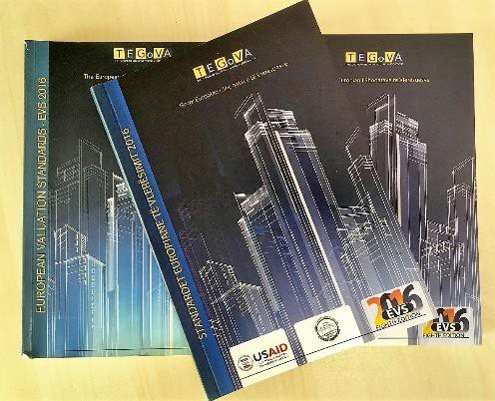
Publish Albanian Language Translation of European Valuation Standards
PRP published the document and will l distribute copies to appraisers, judges, lawyers, notaries and relevant officials. PRP will also seek to have digital version the document posted in the web pages of the Kosovo Association of Appraisers and other institutions.

OBJECTIVE 2: IMPROVED COURT PROCESS RELATED TO PROPERTY CLAIMS

SUB-OBJECTIVE 2.1: CASE FLOW MANAGEMENT REFORMS INSTITUTIONALIZED
Continuing Support for Improved CFM of Property Cases in CoMs. The Peje Basic Court has permanently hired LAs to carry out the functions defined in PRP’s CFM assessments to improve court efficiency. The hired LAs were previously trained and seconded to the court by PRP. The LAs contribution to court efficiency was recognized by the court and the KJC and the position will now become permanent with state funding. The Ferizaj/Urosevac Basic Court also completed its recruitment process and selected LAs that were seconded to the court by PRP. Its decision has been appealed and the process is on-going. PRP expects a final outcome in November 2018.

The Gjilan/Gnjilane Basic Court has not yet commenced its hiring process. PRP will continue to second LAs to the court until it completes the hiring process.

Improved CFM Practices Continue to Produce Positive Results.

Since mid-December 2016, judges in the CoM, with PRP assistance, have issued a total of 10,625 decisions. Of these, 2,059 were to dispose the case, and 8,566 advanced the case more quickly towards disposition.

Dissemination of Decisions of Court of Appeals. PRP continued to distribute the decisions to the CoM. Judges reported the four or five decisions each week are helpful to developing consistent practice.

Coordination with JSSP. PRP and JSSP continued their coordination in connection with the following initiatives:

Joint Publication of Guide for Courts on Civil Practice. The joint publication will combine JSSP’s Bench Book with PRP’s Practical Guide on the Adjudication of Property Rights Cases in Kosovo. JSSP’s sub- contractor produced the first draft of the joint publication, and PRP commenced its review of the draft. The judges authoring the Bench Book expressed great satisfaction with the draft document that now contains more practical guidance for judges to resolve property rights cases which, research shows, pose the most challenges for Kosovo courts. PRP and JSSP have begun discussions to agree sharing the costs of production and publication. PRP expects that it will be published in January 2018.

Training Module on Caseflow Management. JSSP’s STTA expert who is developing the project’s training module on CFM met with PRP and was provided with PRPs assessments and reports documenting the CFM support PRP has provided the CoMs.

SUB-OBJECTIVE 2.2: GUIDELINES DEVELOPED TO UNIFY JUDICIAL PRACTICE IN PROPERTY RIGHTS DISPUTES
Collaboration with the Supreme Court to Develop Guidelines. In the course of its extensive research of the CoM’s processing of property rights cases, PRP identified a number of areas where the courts’ practice is inconsistent, contradictory, and unclear – principally as concerns
(1) the acquisition of rights based on positive prescription; (2) the acquisition of rights based on sale;
(3) the acquisition of rights based on inheritance; (4) the division of joint property (particularly as it impacts the rights of women in inheritance and divorce cases); (5) the acquisition of rights based on co-ownership; (6) the obstruction of possession; and (7) easements.

PRP is collaborating with the Supreme Court to develop guidelines for the lower courts to accurately and consistently resolve problematic issues in property rights adjudication. The development of uniform judicial practice in property rights will help courts adjudicate property cases more effectively and provide citizens with consistent and predictable outcomes to property disputes.

Four judges have been hired to carry out this work – three Supreme Court judges and one judge from the Court of Appeals.

PRP conducted preliminary review of 900 cases in the Supreme Court archives that concern property rights. Of those, PRP selected 139 that bear on the eight types of property rights cases where PRP has identified that judicial practice in unclear and inconsistent. It is expected that the judges will further select most relevant cases and produce summaries to accompany the guidelines. PRP also contracted four Legal Assistants, in consultation with the judges, who will assist the judges to conduct research, draft the case summaries, and provide other assistance.

PRP will support the publication of the guidelines in hard copy and digital formats and will distribute them to judges in all courts. Once the guidelines have been published, PRP will support workshops led by the Supreme Court for judges from the lower courts to acquaint them with the guidelines and foster their understanding and acceptance of the guidelines.
ECHR Case Summaries Produced and Published. By operation of the Kosovo Constitution, the European Convention on Human Rights is directly applicable in Kosovo, as are decisions of the European Court of Human Rights. Yet, because most ECHR decisions issued in French and English languages, many Kosovo policymakers, judges and legal professionals do not have ready access to the Court’s decisions. To help address this situation, PRP produced 144 summaries of the Courts’ decisions and translated them into the Albanian and Serbian languages. The case summaries were drafted by 16 law students-interns who are working under the close supervision of
PRP Products to Assist Judges

- A Practical Guide for Improving Caseflow Management of Property Rights Cases and Other Civil Cases

- Collection of ECHR Case Summaries on Property Rights Issues
three Kosovo law experts. The case summaries are organized around the following categories:

- Expropriation; Nationalization; Compensation

- Restoration of Ownership Rights; Compensation

- Regulation of Property; Interference with Quiet Enjoyment; State Action

- Pension Rights; Employment Benefits; War Reparations

- Contractual Relations; Rent

- Discrimination; Inheritance; Marital Property; Family Matters

- Respect for Property; Family Life

- Currency and Deposits

- Failure to Enforce Judgments; Protracted Procedures; Access to Justice; Judicial Process

- Joint Stock Companies; Reorganization; Employee Rights

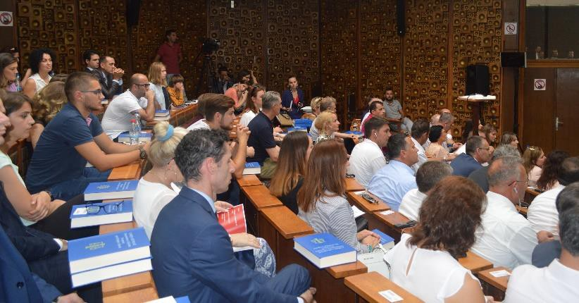
PRP published the summaries and held an event to unveil them to the public. The event was held on July 31, 2018 in the Amphitheater Room at the National Library. The event was well attended by approximately 150 persons. The
attendees included a considerable number of judges; legal professionals; representatives of the legal department from the University of Pristina; and CSO counterparts, along with the three experts and some of the student interns who had drafted the summaries.

Speakers at the event included USAID
Acting Deputy Mission Director and the President of the Supreme Court. Additionally, one of the three experts gave a presentation on the methodology employed in selecting the cases and on the organization of the information presented in the publication and one of the interns shared her experience working on the case summaries.

PRP distributed digital versions of the case summaries in branded USB flash drives, as well hard copies. Over 100 hard copies and flash drives were distributed. PRP will further distribute hard copies to the courts, the Kosovo Bar Association, Ministries and Agencies, municipal administrations and libraries.

The Kosovo Supreme Court and Kosovo Judicial Academy have posted digital versions of the ECHR Case Summaries on their web sites, at the following links:

http://jus.igjk.rks-gov.net/774/

http://www.gjyqesori-rks.org/sq/courts/report/list?id=1&type=1

Development of Training Modules Commenced.

PRP is collaborating closely with the Kosovo Academy of Justice (KAJ) to develop training modules on property rights issues that will be integrated into the KAJ’s formal curriculum. Subjects to be included in the training include:

Gender Sensitivity. The challenges that women in Kosovo face in exercising their property rights freely and fairly, on an equal basis with men, have their roots in traditional attitudes about the “proper” role of women in society.
PRP commenced development of training modules on:

- Gender Sensitivity
- ECHR Practice in Property Rights
- Property Rights Issues in Kosovo Judicial Practice
While legal reforms can play a positive role in bolstering the protections for women’s lawful rights, Kosovo law as it is written is gender-neutral. When the law is being interpreted and applied, however, cultural attitudes often come to the fore and affect the outcome. This module will explore the underlying cultural attitudes and values concerning men and women and prompt participants to confront their own biases and personal views on the subject. While the KAJ has a training module on Kosovo law and gender equality, developed with the assistance of GiZ, the KAJ does not have a module focused on the underlying cultural attitudes and behavior that impede women’s ability to exercise their property rights freely and as men do.

ECHR Practice in Property Rights. This training module will acquaint participants with the fundamental principles and landmark cases enunciated by the Court pertaining to property rights issues, to enable legal professionals to conduct their work in conformity with the European Convention as interpreted by the ECHR.

Property Rights Issues in Kosovo Judicial Practice. As noted above, PRP has identified a number of areas in current judicial practice in property rights where the law is not always fully understood or correctly applied. For example, many property rights cases being adjudicated today require that judges apply previous, Yugoslav law, which is often poorly understood by younger judges. PRP will develop two complementary modules on current property rights practice, which will afford the participants with a basic knowledge of the contours of the laws relevant to property rights cases in Kosovo today.

PRP has identified and hired four local expert consultants to develop the training modules and has convened a working session with the KAJ and its counterpart trainers, with whom PRP’s experts will collaborate closely to finalize the modules. The working session focused on the modalities and methodology for developing the training models, the time table for the work, and coordination among the experts. PRP agreed with the KAJ that the consultants will co-deliver up to four trainings with their KAJ counterparts. PRP would like to extend this training to lawyers, notaries and mediators where appropriate.

PRP has drafted in consultation with USAID a Memorandum of Understanding that will be signed with the KAJ to facilitate cooperation on this initiative. PRP expects the training modules to be completed by December 2018.
Planning Training for Lawyers on Property Rights. PRP met with Mr. Yll Zekaj, Executive Director of Kosovo Bar Association, and Mr. Zekaj agreed to deliver training for lawyers upon the finalization of the training modules by KAJ.

SUB-OBJECTIVE 2.3: EXPEDITED PROCEDURES DEVELOPED
The NSPR recognizes that citizens file contested claims in the courts to obtain legal recognition of undisputed rights because they have no other option. PRP research of the courts’ property rights practice has confirmed that a large number of property cases involve no dispute but are brought to have the court confer recognition of informal property rights. Under current procedural law, the judges have no option but to hear such undisputed claims by applying the Law on Contested Procedure, which results in time-consuming and expensive litigation for citizens and a drain on limited court resources. The NSPR recommends establishing an administrative adjudicatory body using expedited procedures to make it faster and easier for citizens to formalize undisputed rights in property.

As reported previously, PRP has identified the KPCVA as the most appropriate body to conduct expedited procedures to formalize informal property rights, and supported the development of amendments to the Law on the KPCVA to accord the agency with the mandate to formalize informal property rights, owing to an independent local initiative to extend the general mandate of the KPCVA, which is scheduled to come to an end. That work was carried out during the previous Quarter.

During this Quarter, as reported in Sub-Objective 1.2 above, PRP prepared the Explanatory Memorandum and supported a meeting of the working group that prepared the legal amendments to

the KPCVA Law. The Office of the Prime Minister submitted the Draft Law to the Government for adoption, and The GoK has approved the draft and sent it on to the Parliament.

Commencing Initiative to Establish a Property Rights Information Portal (PRIP). The NSPR on Property Rights calls for enhanced procedures to provide effective notification to all persons inside and outside of Kosovo in connection with property rights proceedings in Kosovo that may affect those persons’ rights. PRP believes that the Official Gazette (OG), which has received extensive USAID assistance and has become widely used and respected, would be the logical venue for such an information portal.

PRP developed and presented to Mr. Fehmi Stublla, the acting Director of the Office of the OG (OOG), a concept document and roadmap for developing the PRIP to be hosted on the OG. Mr. Stublla responded favorably to the concept document and requested an MOU to define collaboration between OOG and PRP. PRP developed a draft MOU in consultation with USAID and that is currently under review by the OOG.

Meeting with IT Firm that has upgraded the Official Gazette. PRP also met with Komtel Project Engineering (Komtel) to assess requirements for hosting the PRIP on the OG. Komtel has carried out the three previous technical upgrades of the OG supported by USAID and reported after initial assessment that the upgrade would require changes to some of the source codes but would not require major changes to the current IT architecture.

OBJECTIVE 3: ENHANCED WOMEN’S RIGHTS TO USE PROPERTY IN PRACTICE

SUB-OBJECTIVE 3.1: PUBLIC OUTREACH ON EQUAL PROPERTY RIGHTS FOR WOMEN

Media Campaign

Campaign Banner on Prominent Social Media. PRP has arranged to have the Head Banner on Kallxo.com feature motifs from its media campaign on women’s property rights. The Head Banner has complemented PRP’s billboard campaign and is linked to PRP’s PSA’s on YouTube. https://kallxo.com/.

Supporting RTK Journalist with Information on Women’s Property Rights. USAID directed to PRP a request from RTK journalist Flora Maxharraj for information on women’s property rights. The journalist is designing a program on that topic and was seeking statistical information; information on the role of Kosovo institutions; information on PRP’s media campaign, “For Our Common Good” and its impact on Kosovo society; and help in identifying a few women who are role models in this area that she can interview.

PRP provided the journalist with (i) The Baseline National Survey on Property Rights; (ii) The Midterm National Survey on Property Rights; (iii) PRP’s latest statistics regarding women’s property ownership; and (iv) information on the “For Our Common Good Campaign” and its impact in raising awareness on women’s equal property rights. PRP also provided the journalist with contact information for three women who have property registered in their names; jointly registered marital property; and/or have inherited property.

Support to ATRC and Sub-Grantees

BIRN. PRP has engaged and coordinated actively with the E4E sub-grantee BIRN in connection with its activities in women’s property rights. BIRN has produced story on the draft Law on Inheritance on their web page at Kallxo.com:

https://kallxo.com/projektligji-qe-prek-te-drejtat-e-grave-ne-prone-kalon-pengesen-e-fundit-ne- komision/

BIRN has produced numerous other articles on property rights issues:

- https://kallxo.com/beteja-e-arejta-gashit-per-ndarjen-e-pasurise-me-ish-bashkeshortin-serish-nis- nga-fillimi/
- https://kallxo.com/paraburgim-te-dyshuarit-per-kanosje-te-nje-gruaje-per-shkak-te-prones/

- https://kallxo.com/bie-numri-pronave-te-regjistruara-ne-emer-te-dy-bashkeshorteve/
- https://kallxo.com/usaid-prezanton-vendimet-e-gykates-evropiane-per-te-drejtat-e-njeriut /
- https://kallxo.com/perkthehen-ne-shqip-e-serbisht-144-raste-te-vendimeve-te-gjykates- europiane/
- https://kallxo.com/shtate-kusherinj-perfshihen-ne-rrahje-per-ceshtje-pronesore/
- https://kallxo.com/paraburgim-vellezerve-nga-mamusha-qe-u-perleshen-per-probleme-pronesore/
- https://kallxo.com/rrahen-per-prone-ne-peje/
- https://kallxo.com/ministri-i-drejtesise-paralajmeron-ligjin-per-pronat-publike/
- https://kallxo.com/gjnk/projektligji-per-noterine-dhe-te-drejtat-e-grave-ne-prone/
- https://kallxo.com/paraburgim-te-dyshuarit-per-kanosje-te-nje-gruaje-per-shkak-te-prones/
- https://kallxo.com/prishtine-gruaja-kercenohet-ne-pike-te-dites-per-pronen/
- https://kallxo.com/projektligji-qe-prek-te-drejtat-e-grave-ne-prone-kalon-pengesen-e-fundit-ne- komision/
- https://kallxo.com/hipotekat-ne-kosove-nuk-i-blen-askush/
- https://kallxo.com/llapushnik-mosmarreveshje-per-pronen-arrestohet-nje-person-per-kanosje/

Gruaja Hyjnore. PRP has supported the E4E sub-grantee, “Gruaja Hyjnore,” with information leaflets and brochures for use in their lectures and dissemination activities. Gruaja Hyjnore held number of awareness-raising workshops and meetings with women in the Gjilani/Gnjilane area, including in villages and with high school students.

Public Outreach Events in Municipalities

PRP’s Support to Municipal Gender Officers (MGOs). PRP has continued to work closely with MGOs to foster their active engagement on women’s property rights issues. PRP is working with MGOs from Suharekë/Suva Reka, Mitrovicë/Mitrovica, Lipjan/Ljipjane, Gjakova/Đjakovica, Dragash/Dragaš, Viti/Vitina and Shtërpcë/Šterpce to develop a joint plan of activities in support of women’s property rights. Some of these activities have already begun, while others will be coordinated jointly with MGOs in upcoming months.

Workshop with Local Assembly Women’s Caucus in Suharekë/Suva Reka Municipality. PRP and the MGO organized a workshop with the local assembly women’s caucus and municipal staff.
The aim of the workshop was to sensitize the women’s caucus on the issues surrounding equal property rights in Kosovo. The workshop was divided into three sections: (i) a presentation from the MGO on the local policies regarding gender equality, including MGO’s plans for activities in support to women’s property rights; (ii) a presentation by PRP on issues surrounding women’s equal property rights in Kosovo and (iii) discussion and development of recommendations for next steps. The workshop concluded with a list of recommendations from the participants on how local assembly members and municipal staff can support women’s property rights in their municipality. It is clear that much more work is required to achieve equality for women. Concealment of female heirs and their exclusion from inheritance proceedings continues to prevent women from exercising their legal rights to inherit family property. One of the participants at the workshop noted that he himself had been involved in such an instance when he was asked to witness an Act of Death that was to be used conceal a female heir. Other participants expressed direct and indirect knowledge of similar attempts to conceal or exclude female heirs.

This workshop has also helped the MGO to identify support groups that can be engaged in upcoming outreach and advocacy activities with women and youngsters on women’s equal property rights.

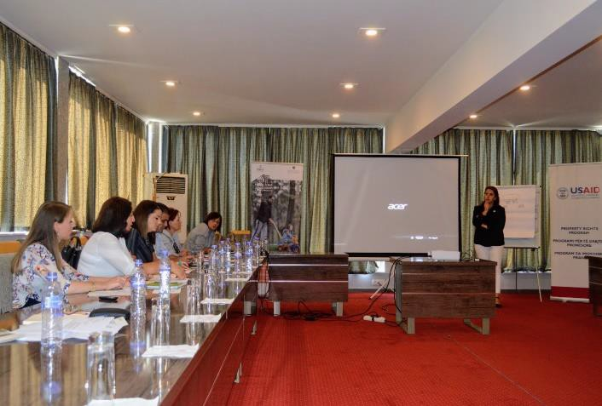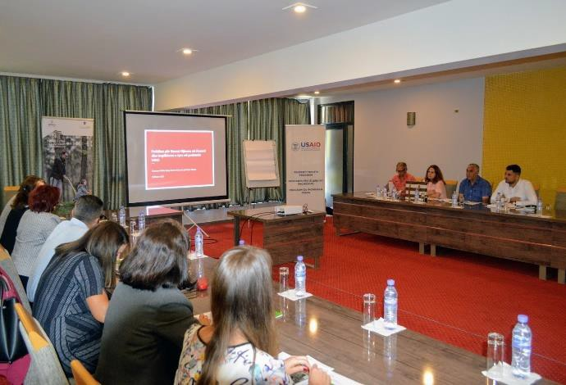

Endline National Survey on Property Rights

Preparations Begun for Endline National Survey on Property Rights. PRP has awarded the subcontract to UBO Consulting (UBO) to conduct the end-line survey. It is expected that UBO will begin its work on or about October 1, 2018 and will complete the survey and issue the report on the findings by the end of February 2019.

As with the baseline and mid-term surveys PRP has conducted to date, the end-line survey will be conducted in all 38 Municipalities of Kosovo, including the four northern municipalities. UBO will survey 1,500 households, which is the number required to produce a statistically significant sample that is representative for the entire country.

SUB-OBJECTIVE 3.2: CONDUCT TRAININGS FOR JUDGES ON WOMEN’S PROPERTY RIGHTS ISSUES AND GENDER SENSITIVITY
Most judges are men, and as members of society they are susceptible to prevailing cultural values. It is important that judges understand how social norms and practices can reduce the ability of women to exercise and protect their rights; and that the courts must dispense justice to men and women equally. As described under Sub-objective 2.2, PRP is developing a training module on gender sensitivity for judges and other professionals that will examine the cultural attitudes that impede women’s ability to exercise their property rights as men do. Training on the Inheritance Package of legislation will be will be offered to judges, lawyers, notaries and mediators when the legislation is adopted into law.

OBJECTIVE 4: IMPROVED COMMUNICATION, ACCESS TO INFORMATION AND UNDERSTANDING OF PROPERTY RIGHTS

SUB-OBJECTIVE 4.1: IMPROVED MUNICIPAL SERVICE DELIVERY AND DISSEMINATION OF LEGAL INFORMATION TO ASSIST CITIZENS TO EFFECTIVELY EXERCISE THEIR RIGHTS TO PROPERTY

Support to All Municipalities (Tier I Support)

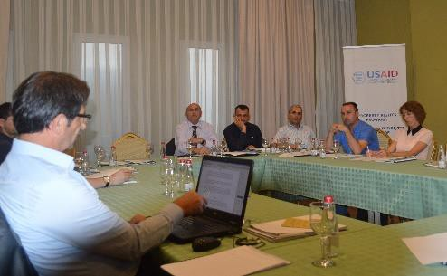
Series of Regional Training Workshops with MCO’s Concluded. PRP completed its series of five regional training workshops on property registration service delivery, with the fifth regional workshop for MCO’s held in Peja/ Peć. Attendance has been good at all the workshops, with MCO staff from 30 municipalities participating, including MCO
staff of the Serb-majority municipalities Gracanicë, Shterpce, Ranillug, Kllokot, Partesh and Leposavic.

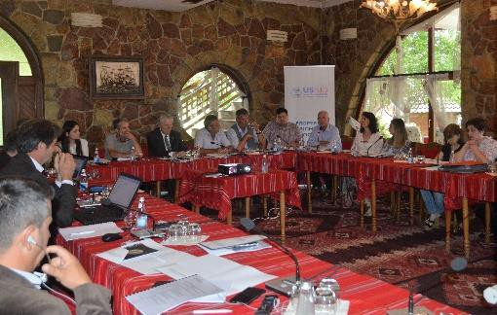
The workshops were designed to focus attention and foster constructive
discussion on specific challenges and problematic issues confronting MCOs that PRP has identified through its work with MCOs in Viti/Vitina and Štrpce/Shtërpcë municipalities, with the ultimate goal of eliciting recommendations that will
foster better and more unified practice within the MCOs.

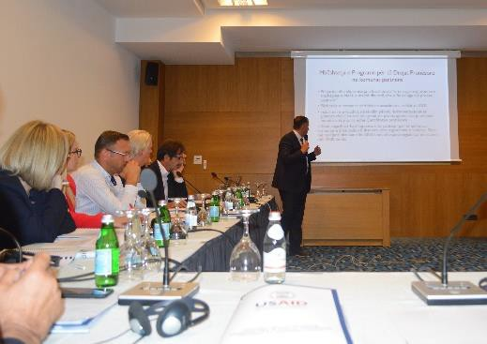
Following the completion of the five regional training workshops, PRP prepared distributed to all the participants in the regional workshops a memorandum (in the Albanian and Serbian languages) that described the issues discussed at all the workshops. The memorandum also drew on the findings from the survey that PRP distributed at the workshops. PRP provided recommendations to address the challenges identified as a prelude to next steps in cooperation and support.

Municipalities Publish the “How to Register …” Brochure Series on their Webpages. At its meetings with the MCO officials PRP, distributed a number of hard-copy brochures that provide citizens with guidance on registering property rights arising in four different scenarios (from inheritance; purchase and sale; court judgment; and gift). PRP has also urged the municipalities to publish the “How to register …” brochures in their municipal webpages to provide their citizens

with easy access to them. (Most of the municipalities noted in their responses in PRP’s questionnaire that the municipalities lack legal information for their citizens).
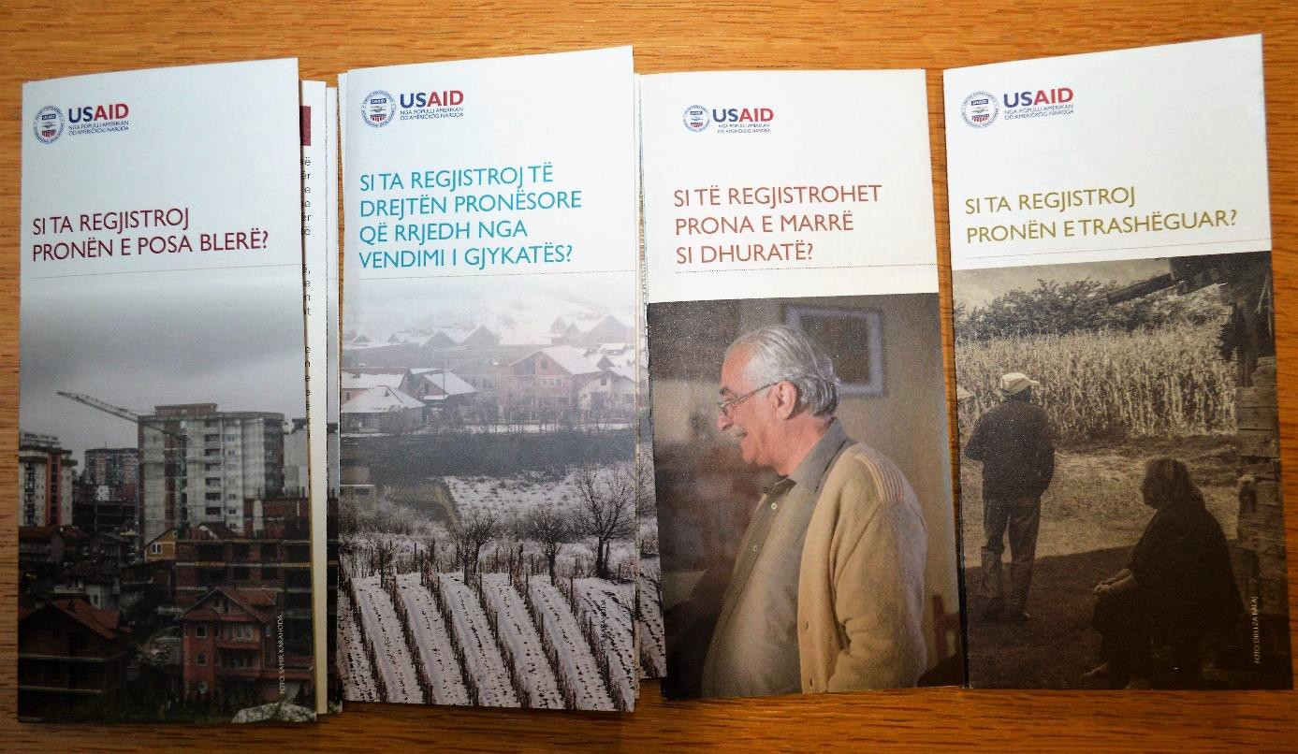
Thus far, eleven municipalities have published the brochures in their municipal webpages, although the Shtërpcë/ Štrpce site is currently off-line. Please note that the Serbian language versions of the municipal websites are under construction. Below are links to the municipalities’ web pages:
Prishtinë/Priština: http://prishtinaonline.com/uploads/alb_si_ta_regjistroj_pronen_te_cilen_porsa_e_kam_blere.pdf
Fushë Kosovë/ Kosovo Polje: https://kk.rks-gov.net/fushekosove/kadaster/udhezuesit-per-regjistrim- te-prones/
Viti/na: https://kk.rks-gov.net/viti/vitia-5/licensa/
Dragash/Dragaš: https://kk.rks-gov.net/dragash/dragash-al/broshura/ Gjakovë/ Đakovica: https://kk.rks-gov.net/gjakove/kadastri-3/dokumentet-dk/
Skenderaj/Srbica: https://kk.rks-gov.net/skenderaj/wp- content/uploads/sites/27/2018/08/combinepdf.pdf
Mitrovicë/Kosovska Mitrovica: https://kk.rks-gov.net/mitroviceejugut/wp- content/uploads/sites/18/2018/01/Hapat-se-si-duhet-te-regjistrohet-prona.pdf
Klinë/Klina: https://kk.rks-gov.net/kline/category/dokumente/ Istog/k: https://kk.rks-gov.net/istog/sherbimet/broshura/
Malishevë/Mališevo: https://kk.rks-gov.net/malisheve/malisheve-2/broshura/
Discussions with Acting CEO of the Kosovo Cadastral Agency (KCA). PRP met with the Acting Chief Executive Officer of KCA, Mr. Avni Ahmeti, to discuss aspects of PRP’s work to date with municipalities and to apprise him of PRP’s next round of activities to support municipalities in matters related to property rights. PRP described the issues discussed with MCO’s at the regional workshops; and discussed plans to upgrade six e-kiosks to enable them to issue property ownership certificates. Mr. Avni was very helpful when PRP was seeking KCA support for e-kiosks that would

issue property certificates; and he reaffirmed the readiness of the KCA to support the work to upgrade additional e-kiosks and assigned a contact person for PRP’s subcontractors.
In addition, PRP used the opportunity to inform Mr. Ahmeti about its plans to assist some municipalities to lease their agricultural land on a commercial basis and requested the KCA for data on municipal holdings of agricultural land who promised cooperation with this, too.
The KCA has included information about this meeting on its website: http://www.kca- ks.org/web/10179/165
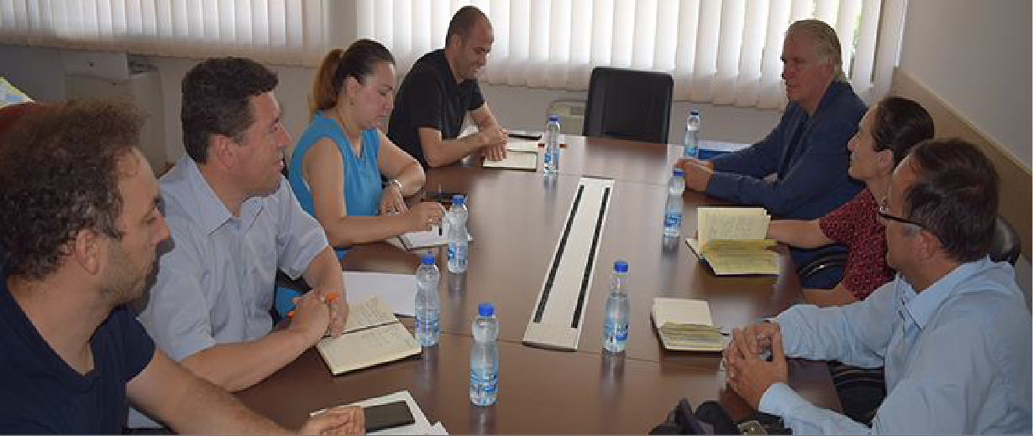

PRP Meets with New Acting Director of MCO in Viti/Vitina. During this Quarter, Viti/Vitina municipality appointed a new acting director of the MCO and PRP used the opportunity to meet him and to inquire about the municipality’s plans to move into its new municipal building, where the archive refurbished by PRP is located. Owing to delays in the final stage of construction, no date has yet been set for the move.
SUPPORT TO SELECTED MUNICIPALITIES (TIER 2 SUPPORT)

Second Generation of E-Kiosks Extended to Four Additional Municipalities. PRP is extending its initiative to create “second generation” e-kiosks to include six existing e-kiosks in four municipalities: Prishtinë/Priština (two e-kiosks), Pejë/Peć (two e-kiosks), Vushtrri/Vučitrn (one) and Graçanicë/Gračanica (one). PRP took the decision to continue this initiative, following its successful creation of the new e-kiosk in Viti/na municipality. The six existing e-kiosks will be upgraded to issue property ownership certificate and certificate as proof for payment of property tax in addition to civil status documents.
PRP held a competitive procurement, selected and concluded contracts with two subcontractors to make the upgrades. The subcontractors have commenced developing the new software.
PRP has also facilitated cooperation between each sub-contractor and the KCA, to enable the subcontractors to establish links between the e-kiosks and the KCA land information system (KCLIS) required for the e-kiosks to issue property certificates.
PRP is also seeking to conclude arrangements with the MoF Property Tax Department so that the upgraded e-kiosks will be able to issue a document that provides proof of payment of property tax, which is required for property registration. This will mark another positive step to improve citizens’ ability to obtain official documents and facilitate property registration. PRP expects to complete this project before the end of this year.

Addressing the Backlog of Unregistered Transactions in Štrpce/Shtërpcë Municipality.

PRP continued to provide STTA to the MCO to eliminate its large backlog of unregistered property transactions. To date around 4,400 files have been entered into the
The Backlog of Unregistered Transactions in Štrpce/Shtërpcë Municipality:
With PRP’s assistance, around 4,400 files have been entered into the KCLIS to date, out of an estimated 5,000 total.
KCLIS, out of an estimated 5,000 total.

The backlog arose when the Municipal Assembly issued an order prohibiting registration of inter- ethnic transactions. The order was subsequently nullified, but during that time the number of transactions that were submitted for registration accumulated, and the MCO did not have the resources to register them and attend to ongoing duties.

In cases where the registration requires graphical (survey) changes in addition to textual changes, the cases are entered into the KCLIS notes as “cases in progress,” pending the entry of the corresponding graphical changes. In such instances, the registrations are searchable, although not complete. At present 1097 cases have been registered in this manner. Responsibility for preparing the graphical data lies with the municipality. PRP is urging the MCO Director to take necessary steps to complete the graphical part of the registrations and enable citizens to receive both property certificates and official copies of the plan for their parcels. MCO Director reported the municipality lacks resources to undertake this action and he has requested support from the KCA. Thus far, support has not been forthcoming.

Municipalities Selected for Leasing Initiative. PRP is developing an initiative to assist targeted municipalities in leasing municipal arable land to the private sector. Following the conclusion of the regional workshops with MCO’s, PRP made fact-finding trips to ten potential partner municipalities to ascertain their officials’ level of support for this initiative. PRP also consulted with USAID AGRO, USAID EMPOWER, USAID P4D and USAID AKT-LS. On the basis of its findings, USAID has approved six partner municipalities including Gjakovë, Peje, Gracanicë, Shtime, Malisheve and Istog.
Analyzing Challenges in Land Consolidation. The NSPR cites the objectives of increasing agricultural productivity and economic growth in Kosovo’s agricultural sector. Land consolidation can greatly further these objectives by bringing increased efficiency and economies of scale to small holdings. But land consolidation in Kosovo faces serious challenges, most principally, informal property rights. Many parcels cannot be included in a land consolidation schemes are not registered to the current “owners” who are using the land, owing to the absence of a formal transfer of property rights through inheritance or to the lack of a written contract evidencing the purchase.

PRP has developed close contacts with the Ministry of Agriculture (MoA), which is responsible for land consolidation, and with the GiZ project that is assisting the MoA in this area. PRP has agreed to assist in amending the current Law on Land Consolidation. PRP developed its own analysis and recommendations of the key issues that should be addressed. These include;

  - Expanding the mandate of the Land Consolidation Commissions to authorize them to formalize informal property rights; and revising the composition of the Commissions, e.g. by including a judge, to support this additional mandate.
  - Subsidizing notary fees.

  - Facilitating purchases and sales between land consolidation participants.
  - Clearly defining the methodology to be followed, e.g., whether a majority of holders by acreage can obligate others to participate in the land consolidation scheme.
  - Providing robust requirements for notifying landowners about the land consolidation initiative.
PRP has provided this analysis to the MoA and GiZ projects and will support them in developing the Concept Document on the new Law on Land Consolidation.

PROJECT SPECIFIC PERFORMANCE INDICATORS

Performance Indicator | DO & IR | Baseline | Target  (Life of Project-Target) | Actual  (Life of Project-Actual)
OBJECTIVE 1: IMPROVE COORDINATION AND POLICY PRIORITIES
1.1} Number of strategies drafted and approved by the government | DO: Improved Rule of Law and Governance that meet Citizen’s Needs  IR: More Efficient, Transparent, Independent & Accountable Justice Sector; Civil Society Strengthened to Increasingly Engage Constructively with Government | 0 | 1 | 2
1.2} Number of laws drafted and approved /Accepted by line ministry/government as a result of USG assistance | DO: Improved Rule of Law and Governance that meet Citizen’s Needs  IR: More Efficient, Transparent, Independent & Accountable Justice Sector; Civil Society Strengthened to Increasingly Engage Constructively with Government | 0 | 6 | 9  (Drafted) 2  (Approved)
1.3} Number of secondary legislation drafted and approved | DO: Improved Rule of Law and Governance that meet Citizen’s Needs  IR: More Efficient, Transparent, Independent & Accountable Justice Sector; Civil Society Strengthened to Increasingly Engage Constructively with Government | 0 | 14 | 26 (4A+22D)
OBJECTIVE 2: IMPROVED COURT PROCESSES RELATED TO PROPERTY CLAIMS
2.1} Number of court procedures and secondary legislation related to court function and/ or improved | DO: Improved Rule of Law and Governance that meet Citizen’s Needs  IR: More Efficient, Transparent, Independent & Accountable Justice Sector | 0 | 12 | 1

Performance Indicator | DO & IR | Baseline | Target  (Life of Project-Target) | Actual  (Life of Project-Actual)
court performance adopted and approved
2.2} Number [average] of days it takes for courts to resolve a property case reduced. | DO: Improved Rule of Law and Governance that meet Citizen’s Needs  IR: More Efficient, Transparent, Independent & Accountable Justice Sector | 1249 | 936 | 9201
2.3} Percent of property disputes cases resolved in courts [within 2 years] | DO: Improved Rule of Law and Governance that meet Citizen’s Needs  IR: More Efficient, Transparent, Independent & Accountable Justice Sector | 32% | 72% | TBD
2.4} Percent of court users satisfied with court services on resolving property disputes | DO: Improved Rule of Law and Governance that meet Citizen’s Needs  IR: More Efficient, Transparent, Independent & Accountable Justice Sector | 22% | 52% | 28%
2.5} Number of judges, lawyers and court staff trained with USG assistance | DO: Improved Rule of Law and Governance that meet Citizen’s Needs  IR: More Efficient, Transparent, Independent & Accountable Justice Sector | 0 | 450 | 118

1 This is valid only for the Courts of Merit, 3 Basic Courts (Gjilan, Peja, and Ferizaj) and 1 Branch Court (Strpce)

Performance Indicator | DO & IR | Baseline | Target  (Life of Project-Target) | Actual  (Life of Project-Actual)
2.6} Number of USG-assisted courts with improved case management related to resolution of property claims and disputes | DO: Improved Rule of Law and Governance that meet Citizen’s Needs  IR: More Efficient, Transparent, Independent & Accountable Justice Sector | 0 | 9 | 42
2.7} Number of legal courses or curricula developed/upgraded with USG assistance | DO: Improved Rule of Law and Governance that meet Citizen’s Needs  IR: More Efficient, Transparent, Independent & Accountable Justice Sector | 0 | 12 | 0
OBJECTIVE 3: ENHANCED ABILITY FOR WOMEN TO ACCESS THEIR PROPERTY RIGHTS IN PRACTICE
3.1} Number of people from civil society and “E4E CSO-s” staff trained to implement program activities in support of USAID/ Kosovo program objectives | DO: Improved Rule of Law and Governance that meet Citizen’s Needs  IR: More Efficient, Transparent, Independent & Accountable Justice Sector; Civil Society Strengthened to Increasingly Engage Constructively with Government | 0 | 80 | 55
3.2} Number of communication outreach products, developed and disseminated by PRP and “E4E CSO-s” | DO: Improved Rule of Law and Governance that meet Citizen’s Needs  IR: More Efficient, Transparent, Independent & Accountable Justice Sector; Civil Society Strengthened to Increasingly Engage Constructively with Government | 0 | 70 | 111
3.3} Number of communication and  outreach campaigns, | DO: Improved Rule of Law and Governance that meet Citizen’s Needs | 0 | 1 | 1

2 PRP is in the process of assisting 4 Basic Courts (Gjilan, Peja, Ferizaj, and the Branch Court of Strpce) with improved case management related to resolution of property claims and disputes.

Performance Indicator | DO & IR | Baseline | Target  (Life of Project-Target) | Actual  (Life of Project-Actual)
developed/supported by USG assistance | IR: More Efficient, Transparent, Independent & Accountable Justice Sector; Civil Society Strengthened to Increasingly Engage Constructively with Government
3.4} Number of communication outreach activities and events developed and implemented by PRP and “E4E CSO-s to change cultural attitudes and behaviors about women’s property rights | DO: Improved Rule of Law and Governance that meet Citizen’s Needs  IR: More Efficient, Transparent, Independent & Accountable Justice Sector; Civil Society Strengthened to Increasingly Engage Constructively with Government | 0 | 114 | 124
3.5} Percentage of citizens who have been reached by PRP and E4E lead social behavior campaign and recognize the PRP and E4E CSO campaign/brand/identity/logo/messa ges/content | DO: Improved Rule of Law and Governance that meet Citizen’s Needs  IR: More Efficient, Transparent, Independent & Accountable Justice Sector; Civil Society Strengthened to Increasingly Engage Constructively with Government | 0 | 40% | 76%
3.6} Percentage of citizens [with negative attitude] who report changing their attitude/behavior about women’s rights to inherit property and engage in economic activities after exposure to PRP  and/or E4E CSO communication | DO: Improved Rule of Law and Governance that meet Citizen’s Needs  IR: More Efficient, Transparent, Independent & Accountable Justice Sector; Civil Society Strengthened to Increasingly Engage Constructively with Government | 36% | 16% | 27%

Performance Indicator | DO & IR | Baseline | Target  (Life of Project-Target) | Actual  (Life of Project-Actual)
and outreach products, activities and events
3.7} Number [percentage] of women who file inheritance claims in the court | DO: Improved Rule of Law and Governance that meet Citizen’s Needs  IR: More Efficient, Transparent, Independent & Accountable Justice Sector; Civil Society Strengthened to Increasingly Engage Constructively with Government | 0.3% | 30% | 3%
3.8} Number [percentage] of women inheriting property | DO: Improved Rule of Law and Governance that meet Citizen’s Needs  IR: More Efficient, Transparent, Independent & Accountable Justice Sector; Civil Society Strengthened to Increasingly Engage Constructively with Government | 3.8% | 33.8% | 7.5%
OBJECTIVE 4: IMPROVED ACCESS TO INFORMATION AND UNDERSTANDING OF PROPERTY RIGHTS
4.1} [Number of] Land administration offices established or upgraded: The number of land administration and service offices or other related facilities that the project physically establishes or upgrades. | DO: Increase Investment and Private Sector Employment  IR: Improved Economic Governance & Business Environment | 0 | 4 | 53

3 PRP has refurbished the archives facility in Viti/Vitina, and is establishing or upgrading e-kiosks with MCO functions in Gjakovë, Vushtrri, Peje and Pristine (in addition to Viti/Vitina).

Performance Indicator | DO & IR | Baseline | Target  (Life of Project-Target) | Actual  (Life of Project-Actual)
4.2} Number of days to conduct property transactions reduced due to improved information systems [in participating municipalities] | DO: Increase Investment and Private Sector Employment  IR: Improved Economic Governance & Business Environment | 33 | 29 | 29
4.3} Number of parcels corrected or incorporated into land system [in participating municipalities] | DO: Increase Investment and Private Sector Employment  IR: Improved Economic Governance & Business Environment | 0 | 440 | 4692
4.4} Land rights formalized [in participating municipalities] | DO: Increase Investment and Private Sector Employment  IR: Improved Economic Governance & Business Environment | 0 | 440 | 4692
4.5} Percent of citizens with increased knowledge of their property rights | DO: Increase Investment and Private Sector Employment  IR: Improved Economic Governance & Business Environment | 27% | 52% | 51%
4.6} Number of municipal officials in participating municipalities trained in property related issues. | DO: Increase Investment and Private Sector Employment  IR: Improved Economic Governance & Business Environment | 0 | 40 | 81

SUCCESS STORY
The PRP project success story is provided on the next page.

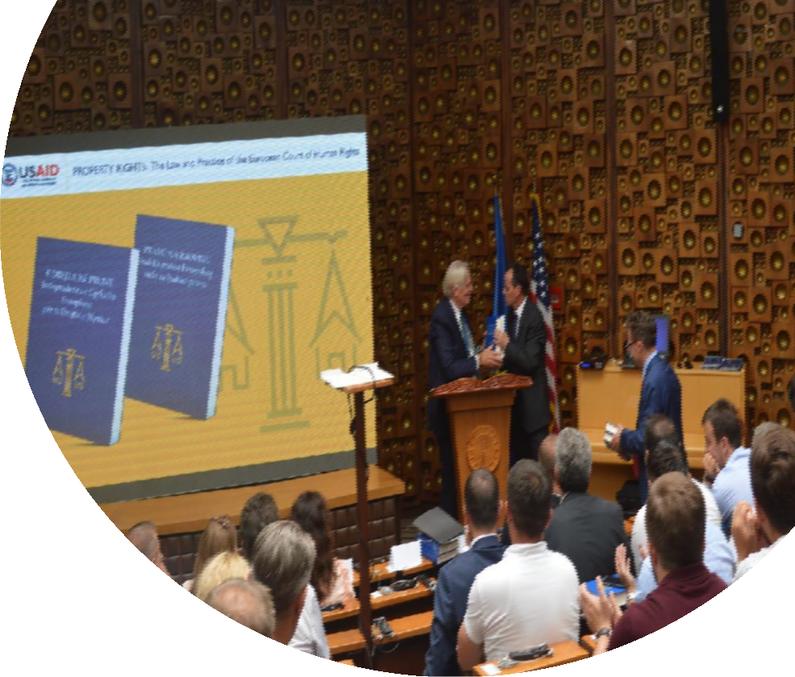

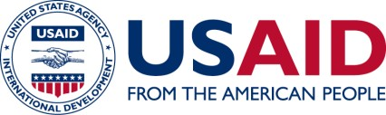

SNAPSHOT
KOSOVO PROPERTY RIGHTS PROGRAM (PRP)
The Kosovo Constitution provides that the European Convention on Human Rights is directly applicable in Kosovo, as are decisions of the European Court of Human Rights (ECHR) in its application of the European Convention. Yet, because most ECHR decisions are issued only in the French and English languages, many Kosovo policymakers, judges and legal professionals do not have ready access to the Court’s decisions. To help address this situation, PRP has produced summaries of 144 key decisions from the European Court of Human Rights that concern property rights. The case summaries were prepared by 16 law students-interns who worked under the close supervision of three Kosovo law experts and translated into the Albanian and Serbian languages.

The case summaries address the following subject areas in property rights;

- Expropriation; Nationalization; Compensation
- Restoration of Ownership Rights
- Regulation of Property; Interference with Quiet Enjoyment; State Action
H. LIMANI / USAID PRP
- Pension Rights; Employment Benefits; War Reparations
- Contractual Relations; Rent
- Discrimination; Inheritance; Marital Property; Family Matters
- Respect for Property; Family Life
- Currency and Deposits
- Failure to Enforce Judgments; Protracted Procedures; Access to Justice; Judicial Process
- Joint Stock Companies; Reorganization; Employee Rights

PRP held an event to present the ECHR Case Summaries to the public. Attendees included many judges; legal professionals; legal scholars; and CSO counterparts. The USAID Acting Deputy Mission

Director and the President of the Supreme Court made remarks, along with one of the three experts and one of the interns. PRP distributed digital versions of the case summaries in branded USB flash drives, as well the hard copies of the book.

PRP has commenced distributing copies to the courts, the Kosovo Bar Association, Ministries and Agencies, municipal administrations and libraries. The Kosovo Supreme Court and Kosovo Judicial Academy have posted digital versions of the ECHR Case Summaries on their web sites, at the following links:

http://jus.igjk.rks-gov.net/774/
http://www.gjyqesori-rks.org/sq/courts/report/list?id=1&type=1

CONTACTS

MISSION

Arberia (Dragodan) Pristina, Kosovo, 10130
Tel: +381 (0)38 59 59 2000
Fax: +381 (0)38 249 493
www.usaid.gov/kosovo

HEADQUARTERS

U.S. Agency for International Development 1300 Pennsylvania Avenue, NW Washington, DC, USA 20523 www.usaid.gov

PROJECT BRIEF UPDATE
The PRP project brief update is provided on the next page.

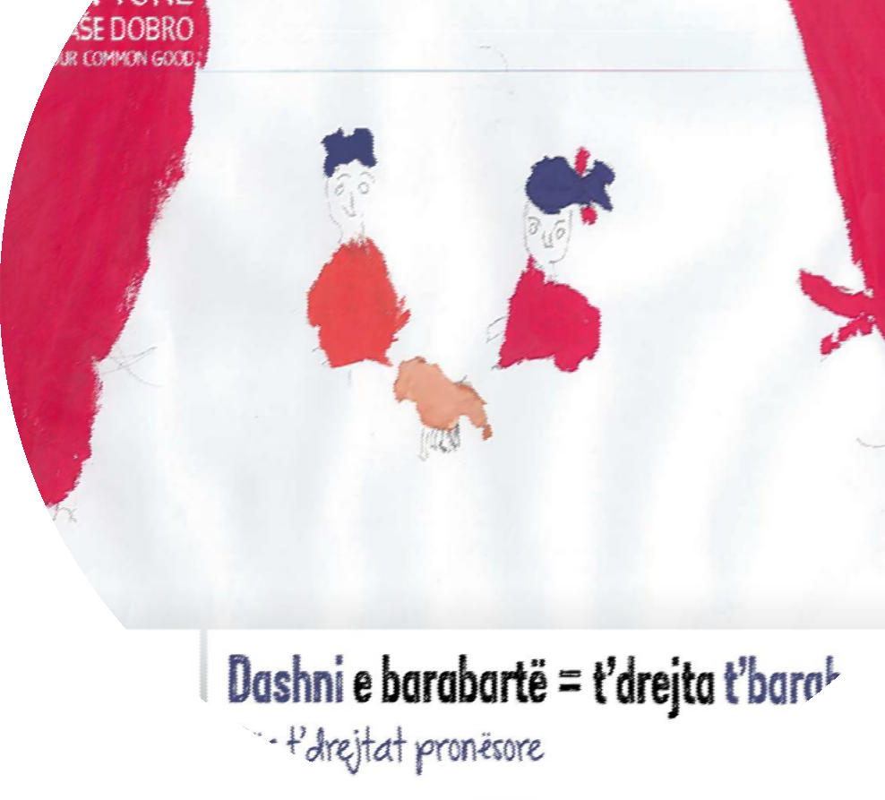

PROJECT BRIEF UPDATE KOSOVO PROPERTY RIGHTS PROGRAM (PRP)

The rule of law in Kosovo is constrained by poorly defined and enforced property rights, especially the property rights of women and members of minority communities. The absence of an effective property rights regime weakens democratic governance, impacts human rights, disempowers women and impedes sustainable economic growth.
The overall goal of the program is to improve the property rights regime in Kosovo, strengthen the rule of law, and increase economic growth and investment. The Property Rights Program (PRP) is implemented under four objectives:
D. CUIZON / USAID PRP

Objective 1: Better Coordination and Policy Priorities

Objective 2: Improved Court Procedures Related to Property Claims Objective 3: Enhance Women’s Rights to Use Property in Practice
Objective 4: Improved Communication, Access to Information and Understanding of Property Rights

OUR WORK
This Quarter saw PRP advance its initiatives significantly under all four Objectives.

Objective 1: PRP has continued to work with GoK partner institutions to develop the legislation necessary to implement the National Strategy on Property Rights, which the GoK developed with PRP support. The GoK adopted the National Strategy in January 2017. To date, action has been taken on 89% of the pieces of legislation contemplated by the three-year NSPR Action Plan, and the Government has begun implementing 66% of measures called for by the Action Plan. Activities are being implemented on time cross all five NSPR objectives. A total of 12 pieces of draft legislation are currently under development, including the Law on Public Property; the Law on Construction Land; the Law on Sale of the Apartments in which a Tenure Right Exists; the Law on Cadastre; and the Concept Document on the Transformation of Socially Owned Property.

In addition, Parliament is currently reviewing the “Inheritance Package” of legislation; the draft Law on the Kosovo Comparison and Verification Agency; and the Draft Law on Allocation for the Use and Exchange of Municipal Property.

PRP has also produced and disseminated its Albanian translation of European valuation standards.

Objective 2: The caseflow management (CFM) reforms PRP has been piloting in its three Courts of Merit (CoM) continue to increase significantly the number of decisions that the courts are taking and are also enabling them to address cases that have been delayed or neglected (i.e., backlogged cases – cases that have been on the docket for over two years). Thus, the improved CFM practices have increased the courts’ ability to deal effectively with their caseloads and prevent significant backlogs from arising.

In addition, PRP is moving forward with its initiative with the Supreme Court to assist the Supreme Court to develop guidelines on judicial practice in the area of property rights, in the key areas identified by PRP in its work with courts of first instance.

Furthermore, PRP has succeeded in using an initiative to extend the general mandate of the Kosovo Property Comparison and Verification Agency (KPCVA) to include draft amendments giving the KPCVA the authority to formalize informal property rights acquired through informal transactions occurring prior to 1999. The amendments to the Law on the KPCVA are in Parliament.

Moreover, PRP produced it 700-page volume, in Albanian and Serbian, of summaries of 144 key decisions of the European Court of Human Rights that concern property rights.

Objective 3: PRP’s National Survey on Property Rights demonstrates that PRP’s media campaign has sparked debate and discussion in Kosovo concerning women’s property rights (which was reportedly a taboo subject previously) and is producing positive changes in social attitudes and behaviors. PRP is continuing its national media campaign and grassroots public outreach activities on women’s property rights to reinforce these trends. PRP also provides technical assistance to USAID’s E4E partner and E4E sub-grantees (Civil Society Organizations (CSOs)) to develop and implement activities aimed at supporting women’s property rights and to complement PRP’s public outreach activities. In addition, PRP has completed preparations for the third and final (Endline) National Survey on Property Rights.

Objective 4: PRP has moved forward a number of initiatives that are designed to improve municipal governments’ services to their citizens. PRP has completed its series of five regional workshops for Municipal Cadastral Offices (MCO’s) that are designed to focus their attention and foster constructive discussion on specific challenges and problematic issues affecting property registration. Officials from 30 municipalities took active part in the workshops. PRP has continued its support to address a significant backlog of un-registered cadastral files; and is moving forward with installing second-generation e-kiosks in four additional municipalities that issues property rights documents, PRP also completed its research and analysis and has identified six municipalities that PRP will assist with leasing municipal land to the private sector.

CONTACTS

MISSION
Arberia (Dragodan) Pristina, Kosovo, 10130
Tel: +381 (0)38 59 59 2000
Fax: +381 (0)38 249 493
www.usaid.gov/kosovo

HEADQUARTERS

U.S. Agency for International Development 1300 Pennsylvania Avenue, NW Washington, DC, USA 20523 www.usaid.gov

MEDIA

PUBLICATIONS
The following print and digital publications covered PRP Activities this quarter.

Kallxo.com

‘144 cases of European Court decisions are translated into Albanian and Serbian’ https://kallxo.com/perkthehen-ne-shqip-e-serbisht-144-raste-te-vendimeve-te-gjykates-europiane/ July 31, 2018

Kallxo.com

‘The draft law affecting women's property rights passes the last barrier’ https://kallxo.com/projektligji-qe-prek-te-drejtat-e-grave-ne-prone-kalon-pengesen-e-fundit-ne- komision/
September 19, 2018

PROJECT STAFF

CATEGORY | NO | NAME AND SURNAME | POSITION/ EXPERTISE | E-MAIL ADDRESS |  |  | ORGANIZATION | INPUT
Home Office | 1. | Mr. Brian Kemple | Chief of Party | brian.kemple@prpkos.com |  |  | Tetra Tech ARD | Ongoing
 | 3. | Mr. John (Jack) Keefe | Project Manager (Technical) | jack.keefe@tetratech.com |  |  | Tetra Tech ARD | Ongoing
 | 3. | Mr. Thomas McCann | Deputy Project Manager (Administrative) | thomas.mccann@tetratech.com |  |  | Tetra Tech ARD | Ongoing
Kosovo Local Staff | 1. | Mr. Xhevat Azemi | Senior Policy Development Specialist | xhevat.azemi@prpkos.com |  |  | Tetra Tech ARD | Ongoing
 | 2. | Mr. Enver Fejzullahi | Senior Judicial Reform Specialist | enver.fejzullahi@prpkos.com |  |  | Tetra Tech DPK | Ongoing
 | 3. | Ms. Merita Limani | Gender and Property Rights Specialist | merita.limani@prpkos.com |  |  | Tetra Tech ARD | Ongoing
 | 4. | Mr. Nehat Ramadani | Municipal Service Delivery Specialist | nehat.ramadani@prpkos.com |  |  | Tetra Tech ARD | Ongoing
 | 5. | Ms. Eremira Salihu | Municipal Processes Analyst | eremira.salihu@prpkos.com |  |  | Tetra Tech ARD | Ongoing
 | 6. | Mr. Gent Salihu | Senior Rule of Law and Governance Advisor | gent.salihu@prpkos.com |  |  | Tetra Tech ARD | Ongoing
 | 7. | Ms. Vjosa Shkodra | Special Advisor on Rule of Law and Civil Society | vjosa.shkodra@prpkos.com |  |  | Tetra Tech ARD | Ongoing
 | 8. | Mr. Driton Zeqiri | Monitoring and Evaluation Specialist | driton.zeqiri@prpkos.com |  |  | Tetra Tech ARD | Ongoing
 | 9. | Ms. Hana Limani | Communications and Public Outreach Mgr. | hana.limani@prpkos.com |  |  | Tetra Tech ARD | Ongoing
 | 10. | Mr. Fadil Sadiku | Administration Manager | fadil.sadiku@prpkos.com |  |  | Tetra Tech ARD | Ongoing
 | 11. | Mr. Sherafedin Shehu | Accounting and Finance Manager | sherafedin.shehu@prpkos.com |  |  | Tetra Tech ARD | Ongoing
 | 12. | Mr. Sejdi Mustafa | Driver & Administrative Assistant | sejdimustafa74@gmail.com |  |  | Tetra Tech ARD | Ongoing
 | 13. | Ms. Kreshnike Zymberi | Court Record Management Spc. (Ferizaj/Uroševac) | kreshnike.zymberi@prpkos.com |  |  | Tetra Tech DPK | Ongoing
 | 14. | Ms. Kaltrina Haliti | Court Record Management Spc. (Gjilan/Gnjilane) | kaltrina.haliti@prpkos.com |  |  | Tetra Tech DPK | Ongoing
 | 15. | Ms. Etleva Kelmendi | Legal Advisor for Obj. 2 | etleva.kelmendi@prpkos.com |  |  | Tetra Tech DPK | Ongoing
 | 16. | Mr. Irfan Thaqi | Court Legal Associate (Gjilan/Gnjilane) | irfan.thaqi@prpkos.com |  |  | Tetra Tech DPK | Ongoing
 | 17. | Ms. Gentiana Shabani | Court Legal Associate (Gjilan/Gnjilane) | gentian.shabani@prpkos.com |  |  | Tetra Tech DPK | Ongoing
 | 18. | Mr. Driton Ahmeti | Court Legal Associate (Ferizaj/Uroševac) | driton.ahmeti@prpkos.com |  |  | Tetra Tech DPK | Ongoing
 | 19 | Mr. Fatlum Halimi | Court Legal Associate (Ferizaj/Uroševac) | fatlum.halimi@prpkos.com |  |  | Tetra Tech DPK | Ongoing

U.S. Agency for International Development Kosovo
Arberia (Dragodan) Pristina, Kosovo, 10130
Tel: +381 (0)38 59 59 2000
Fax: +381 (0)38 249 493
www.usaid.gov/kosovo

